

**Information note**

**SDMX Global Conference 2017**

**October 2-5, 2017, Addis Ababa, Ethiopia**

**Hosts**

[United Nations Economic Commission for Africa (ECA)](http://www.uneca.org/pages/overview), and [African Development Bank (AfDB)](https://www.afdb.org/en/).

**Venue**

The meeting will be held in the [ECA Conference Centre (ECACC)](http://www.uneca.org/ecacc), Menelik II Ave., Addis Ababa, Ethiopia.

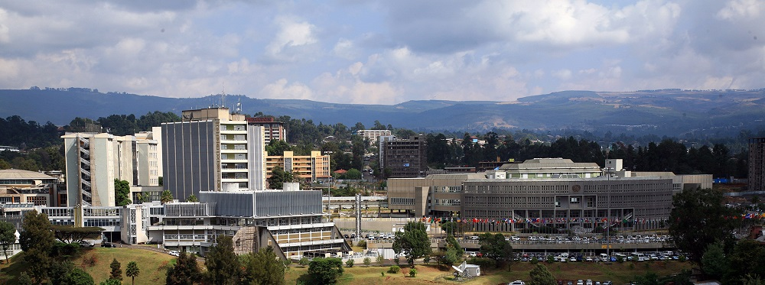

# Immigration requirements

All participants coming from countries in which there are Ethiopian embassies or consulates are strongly advised to obtain their Ethiopian visas prior to arrival in Ethiopia.

For participants who are not able to process their visas in advance, ECA will make a request for them to be given business visas upon arrival at Bole International Airport.

In order to assist participants in obtaining visas upon arrival, the secretariat (Hiwot Debebe Kebede - [debebeh@un.org](mailto:debebeh@un.org?subject=SDMX%202017%20Global%20Conference%20Addis%20Ababa)) needs to receive the following particulars at least **five working days** before arrival at Bole International Airport:

1. Full name;
2. Nationality;
3. Flight details (arrival and departure).

Participants requesting visas upon arrival should carry with them their personal **official letter of invitation** for the event, so that they can show it to the immigration authorities at Bole International Airport.

Please note that an Ethiopian visa costs US$ 30 or the equivalent in euros per person. Payment must be made in either US dollars or in euros at the time of issue. For media, the cost of a visa is US$ 40 or the equivalent in euros. Holders of diplomatic and service passports and United Nations *Laissez-Passer* will receive visas gratis.

Bank receipts for money changed at the airport must be kept securely as they may be asked for upon departure.

# Health requirements

Visitors to Ethiopia should be in possession of a valid health certificate for yellow fever. Vaccination against cholera is also required for anyone who has visited or transited a cholera-infected area within six days prior to arrival in Ethiopia. As Addis Ababa is situated at an altitude of 2,400 metres, it is advisable to take precautionary measures to avoid any health problems that might occur because of the high altitude.

The United Nations Health Care Centre, situated on the ground floor of the Conference Centre, can provide emergency medical services to participants and delegates attending the Conference.

In case of a medical or dental emergency, please contact:

Dr. Grace Fombad

Chief, United Nations Health Care Centre

Telephone: + 251 (0) 115 51 58 28 or 51 72 00; ext. 88888 or 448888

ECA Ambulance: + 251 (0) 115 51 42 02 or 51 58 28

# Guidelines on personal security and safety of participants

The United Nations Security and Safety Service is always ready to serve its clients. In this regard, the full cooperation of all participants is needed to ensure the safety of your valuables and your personal security.

While you are on ECA premises, please ensure that you:

* show your conference badge to any authorized person who asks to see it, and wear it visibly;
* do not leave bags and parcels unattended, as they may be confiscated or destroyed;
* do not bring unauthorized persons and children into the Conference Centre;
* look after your valuable property;
* check that you have all your documents and personal items before you leave conference halls and meeting rooms;
* inform the Security and Safety Service or the nearest Security Officer if you lose anything valuable.

When you are in your hotel, please follow this safety advice:

* upon entering or leaving your room, make it a habit to lock the door;
* before leaving, inspect your room to make sure that no money, jewellery, cameras, etc. are visible;
* deposit valuables or portable items at the reception desk and obtain a receipt;
* should you observe anything suspicious or out of the ordinary, please contact the Security and Safety Service.

## Useful telephone numbers

## Emergency numbers

UN Control Room (24 hrs) +251 – 115 445135 / 516537 / 512945

Security Chief +251 – 0911 201802

Deputy Chief +251 – 0911 508578

## Emergencies outside of Addis

UN Operations Centre (24 hrs) +251 – 115-511726

Satellite phone +87162546835

Police Emergency Numbers (24 hrs) 991

City Police +251 – 115 572100 / 572121

Federal Police +251 – 115 524077 / 526302 / 526303

# Airline reservations

A number of international airlines operate to and from Addis Ababa. Participants must secure their return/onward air passage prior to arrival in Addis Ababa. There are two official travel agencies in the ECA compound – Gashem Travel and Airlink Travel – that can assist with re-confirmation of tickets and provide participants with travel and tour-related information.

Gashem Travel Tel: +251 115 44 30 51 / 44 30 52 / 46 84 85 or +251 0911 25 04 68 (mobile)

Airlink Travel Tel: +251 115 44 43 33/ 44 43 34/ 44 43 65 or 44 43 37

Ethiopian Airlines and Kenya Airways also have offices in the ECA compound, in the Rotunda.

Please have your ticket with you when visiting the travel agencies and the airlines to re-confirm your flights.

# Hotel accommodation

**Participants must contact the hotels directly to arrange, confirm and guarantee their bookings.**

In addition to accommodation costs, all participants will be responsible for all other additional costs – i.e. breakfast (where not included), telephone, internet/fax, room service, mini-bar, laundry, other meals (lunch and dinner) – and must pay for these directly when checking out.

The following hotels have been identified for Conference participants.

|  |  |  |  |
| --- | --- | --- | --- |
| **Hotel** | **Type of Rooms** | **UN Rate** | **No. of Rooms** |
| **Special Hotels** | | | |
| **SHERATON HOTEL**  Tel: (251-11) 5 17 17 17  Fax: (251-11) 5 17 27 27  E-mail: [reservations.addisethiopia@luxurycollection.com](mailto:reservations.addisethiopia@luxurycollection.com)  Website: [www.luxurycollection.com/addis](http://www.luxurycollection.com/addis) | Club (single)  Double  Executive  Executive Double | US$ 255.00  US$ 255.00  US$ 366.00  US$ 410.00  **Plus 26.5% tax** | 293 |
| **HILTON HOTEL**  Tel: (251-11) 5 51 84 00/17 00 00  Tel: (251-11) 5 51 00 64  Fax: (251-11) 5 51 17 18  Email: [reservations.addisababa@hilton.com](mailto:reservations.addisababa@hilton.com) | Single  Double  Executive  Corner Suite | US$ 195.00  US$ 210.00  US$ 260.00  US$ 290.00  **Plus 26.5% tax** | 372 |
| **RADISSON BLU HOTEL**  **Tel:** (251-11) 5-15 76 00/ 17 04 00  **Fax:** (251-11) 5-15 76 01  E-mail: [feven.yirga@radissonblu.com](mailto:feven.yirga@radissonblu.com)  [reservations.addisababa@radissonblu.com](mailto:reservations.addisababa@radissonblu.com)  Website: [www.radissonblu.com](http://www.radissonblu.com) | Single Standard | US $125.00  **Plus 26.5% tax** | 204 |
| **MARRIOTT EXECUTIVE APARTMENTS**  Tel: (251-11) 5 18 46 00  E-mail: [reservation.adder@marriott.com](mailto:reservation.adder@marriott.com)  Website: [www.marriott.com/adder](http://www.marriott.com/adder) | Single  Double | US $160.00  US $175.00  **Plus 26.5% tax** | 81 |
| **Other Hotels** | | | |
| **APHRODITE HOTEL**  **Tel:** (+251-11) 5 57 22 20/00/32/ 28  **Fax:** (+251-11) 5- 572204  E-mail. [reservation@aphroditeaddis.com](mailto:reservation@aphroditeaddis.com)  [aphroditeinthotel@gmail.com](mailto:aphroditeinthotel@gmail.com)  Website: [www.aphroditeaddis.com](http://www.aphroditeaddis.com) | Single Standard | US$ 90.00 | 52 |
| **CAPITAL HOTEL AND SPA**  **Tel:** 251-11 6-672100  251-11-6-192000  **Fax:** 251-11-6-672012  E-mail: [bfikre@capitalhotelandspa.com](mailto:bfikre@capitalhotelandspa.com)  [reservation@capitalhotelandspa.com](mailto:reservation@capitalhotelandspa.com)  Website: [www.capitalhotelandspa.com](http://www.capitalhotelandspa.com) | Single Standard | US$ 120.00 | 114 |
| **CHURCHILL HOTEL**  **Tel:** (251-11) 1 11 12 12  **Fax:** (251-11) 1 11 88 00  Tsegireda – 0913139125  E-mail: [churchillhotel@ethionet.et](mailto:churchillhotel@ethionet.et) | Single | US$ 75.00 | 53 |
| **DREAMLINER HOTEL**  Tel: (251-11) 4 67 40 00  Fax: (251-11) 4 67 40 01  Email: [dreamlinerhotel@ethionet.et](mailto:dreamlinerhotel@ethionet.et)  [reservation@dreamlinerhotel.com](mailto:reservation@dreamlinerhotel.com)  Website: [www.dreamlinerhotel.com](http://www.dreamlinerhotel.com) | Standard Single  Standard King | US$ 80.00  US$ 100.00 | 96 |
| **ELILLY HOTEL**  **Tel:** 0115- 58 77 77**/73/70**  **Fax:** 0115 58 52 00  E-mail: [info@elillyhotel.com](mailto:info@elillyhotel.com)  [reservation@elillyhotel.com](mailto:reservation@elillyhotel.com)  Website: [www.elillyhotel.com](http://www.elillyhotel.com) | Standard | US$ 100.00 | 154 |
| **GETFAM HOTEL**  **Tel:** (251-11) 6 67 31 75 E-mail: [contactus@getfamhotel.com](mailto:contactus@getfamhotel.com)  Website: [www.getfamhotel.com](http://www.getfamhotel.com) | Standard  Twin  Junior Suite  Suite  Presidential | US$ 100.00  US$ 100.00  US$ 172.00  US$ 250.00  US$ 450.00 | 115 |
| **HARMONY HOTEL**  Tel: (251-11) 6 18 31 00  Fax: (251-11) 6 18 29 10  E-mail: [info@harmonyhotelethiopia.com](mailto:info@harmonyhotelethiopia.com)  Website: [www.harmonyhotelethiopia.com](http://www.harmonyhotelethiopia.com) | Sheba Queen  Standard Twin | US$ 118.00  US$ 118.00 | 150 |
| **INTERCONTINENTAL HOTEL**  Tel: (251-11) 5 50 50 66/18 04 44  Fax: (251-11) 5 54 00 90/96  E-mail: [reservation@intercontinentaladdis.com](mailto:reservation@intercontinentaladdis.com)  Website: [www.intercontinentaladdis.com](http://www.intercontinentaladdis.com) | King Deluxe (Standard)  Double occupancy  Twin Deluxe | US$ 120.00  US$ 158.00  US$ 158.00 | 152 |
| **JUPITER INTERNATIONAL HOTEL – BOLE**  Tel: (251-11) 6 61 69 69/70  Fax: (251-11) 6 61 69 99  E-mail: [info@jupiterinternationalhotel.com](mailto:info@jupiterinternationalhotel.com)  Website: [www.jupiterinternationalhotel.com](http://www.jupiterinternationalhotel.com) | Standard  Deluxe  Twin  Junior Suite  Executive | US$ 100.00  US$ 120.00  US$ 140.00  US$ 155.00  US$ 200.00 | 40 |
| **JUPITER INTERNATIONAL HOTEL - KASANCHES**  Tel: (251-11) 5 52 73 33  ( 251-11) 5 52 63 70  0911 65 18 10 (Ayelech)  Fax: (251-11) 5 52 64 18  E-mail: [info@jupiterinternationalhotel.com](mailto:info@jupiterinternationalhotel.com)  Website: [www.jupiterinternationalhotel.com](http://www.jupiterinternationalhotel.com) | Standard Single  Deluxe  Twin  Junior Suite  Executive | US$ 100.00  US$ 120.00  US$ 140.00  US$ 155.00  US$ 200.00 | 102 |
| **KALEB HOTEL**  **Tel:** (251-11) 6-62-22-00  **Fax:** (251-11) 6-62-80-98  E-mail: [reservation@kalebhotel.com](mailto:reservation@kalebhotel.com)  Website: [www.kalebhotel.com](http://www.kalebhotel.com) | Single Standard | US$ 85.00 | 64 |
| **MONARCH**  Tel: (251-11) 6 67 24 80/81/82  E-mail: [info@monarchaddis.com](mailto:info@monarchaddis.com)  Website: [www.monarchaddis.com](http://www.monarchaddis.com) | Standard Single  Deluxe  Twin  Deluxe Studio | $75.00  $75.00  $100.00  $90.00 | 74 |
| **NIGIST TOWERS GUEST HOUSE**  **Tel:** (251-11) 5 50 97 70  Yirgat: 0911 19 55 35  E-mail: [info@nigisttowers.com](mailto:info@nigisttowers.com)  Website: [www.nigisttowers.com](http://www.nigisttowers.com) | Studio  One Bed  Two Bed | US$ 72.45  US$ 84.53  US$ 114.70 | 32 |
| **RAMADA HOTEL**  Tel: (251-11) 6 39 39 39  Email: [info@ramadaaddis.com](mailto:info@ramadaaddis.com)  Website: [www.ramadaaddis.com](http://www.ramadaaddis.com) | Superior | US $115.00  **Plus 26.5% tax** |  |
| **SARO MARIA HOTEL**  **Tel:** 0116- 67 21 67/68  **Fax:** 0116- 67 21 21  E-mail: [info@saromariahotel.com](mailto:info@saromariahotel.com)  Website: [www.saromariahotel.com](http://www.saromariahotel.com) | Single Standard  Double | US$ 90.00  US$ 120.00 | 96 |
| **WASHINGTON HOTEL**  Tel: (251-11) 6-39 22 39  Fax: (251-11) 6-39 21 83  E-mail: [info@washingtonaddis.com](mailto:info@washingtonaddis.com)  Website: [www.washingtonaddis.com](http://www.washingtonaddis.com) | Single  Twin | US$ 85.00  US$ 95.00 | 65 |
| **WASSAMAR HOTEL**  Tel: (251-11) 6-61-00-55  Fax: (251-11) 6-61-00-65  E-mail: [info@wassamarhotel.com](mailto:info@wassamarhotel.com)  Website: [www.wassamarhotel.com](http://www.wassamarhotel.com) | Single  Double | US$ 85.00  US$ 95.00 | 66 |

**Arrival at Bole International Airport**

Addis Ababa Bole International Airport is located on the Southern outskirts of the capital city, about 8 km from the city centre, at an elevation of 2325 m.

Taxis are immediately available at Bole International Airport. They also can be found outside most hotels in Addis Ababa and at the country’s major centres.

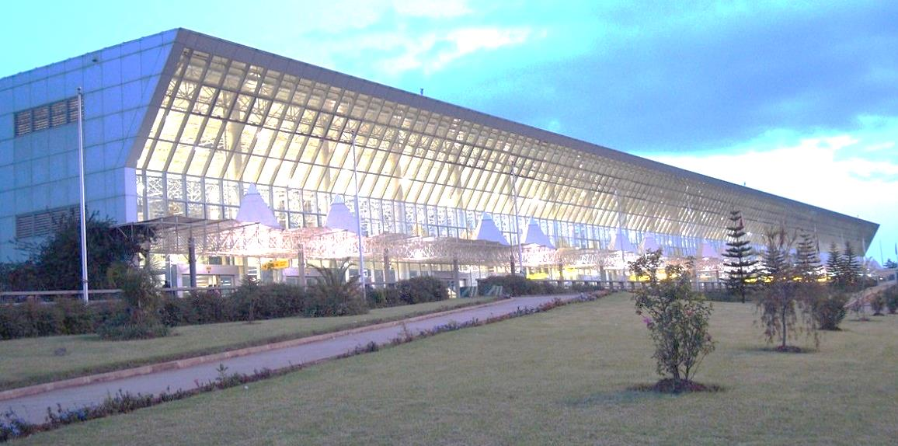

# Registration and identification badges

Participants will be required to register and obtain identification badges prior to the start of the Conference.

For security reasons, identification badges should be worn by all participants at all times, during the Conference as well as during official social functions.

## Registration will start from Monday, 2 October 2017, and will take place at the Delegates Registration Building, which is located at the pedestrian entrance of the ECA compound.

# ICT services

The ECA Conference Centre is equipped with Wi-Fi. Technical support is available through the ECA Help Desk (tel.: +251 115443123; ext.: 33123; [ihelpdesk@uneca.org](mailto:ihelpdesk@uneca.org)). Technical support for presentations must be arranged in advance with the Conference Centre support team.

Please be advised that Blackberry services are not available in Ethiopia.

# Catering facilities

Catering facilities for refreshments and meals within the ECA compound include:

* Sheraton Addis, located in the Conference Centre;
* Harambe Restaurant, located in the Nile Building;
* Kaldis Coffee, located in the Rotunda, near the Africa Hall;
* Tivoli Cafeteria, located in the Green House.

# Mobile phones

Participants are encouraged to bring with them a dual band mobile handset (900/1800 MHZ). The Ethiopian Telecommunication Company (ETC) sells SIM cards with pre-charged airtime. The total package costs 40 Ethiopian birr, which includes 15 birr-worth of airtime. It takes approximately two days to have an ETC mobile phone connected.

# General information about Ethiopia

Ethiopia is as large as France and Spain combined. Addis Ababa is situated at an altitude of 2,400 metres. Agriculture is the backbone of the national economy, and the principal exports from this sector include coffee, oil seeds, pulses, flowers, vegetables, sugar and animal feed. About 90 per cent of the population earns its living from the land. There is also a vibrant livestock sector, and exports include cattle, hides and skins.

The population of Ethiopia is estimated at 100 million, and over 50 per cent of the population is under 20 years of age. The average number of inhabitants per square kilometre is 69. Ethiopia is a multi-ethnic state with a great variety of spoken languages. There are 83 languages with 200 dialects, and the three main languages are Amharic, Tigrigna and Oromigna. English, French, Italian and Arabic are also spoken, mainly in Addis Ababa. Additional information on Ethiopia and ECA can be found online at [http://www.uneca.org](http://www.uneca.org/), http://www.ethionet.et and [http://tour.ethiopianonline.net](http://tour.ethiopianonline.net/).

# Climate

Ethiopia has two main seasons. The dry season lasts from October to May, and the rainy season starts in late June and ends in September. Temperatures depend on the season and altitude.

The weather is likely to be cold at night in October, so please ensure that you bring a warm jacket or sweater.

# Electricity

Electric supply in Ethiopia is 220-240 volts, 50 cycles AC accessible via 13 amp, two-pin (European) socket.

# Currency (Ethiopian birr)

Ethiopian currency is denominated in “[birr](http://www.nbe.gov.et/aboutus/notesgallery.html)” and “centimes”. The exchange rate fluctuates. The official exchange rate of the United Nations was **US$ 1.00 = ETB 23.03** as of July 2017.

There is a branch of the Commercial Bank of Ethiopia in the ECA compound, in the Rotunda. The bank is open Monday–Friday, from 8 a.m. to 5.30 p.m. There is also an authorized exchange centre (Forex) at the Sheraton Hotel, and ATM machines for Visa/MasterCard users in the Conference Centre and at the Sheraton, Hilton, Radisson Blu, Intercontinental, Ethiopia and Wabe Shebelle hotels, which will give you money in birr.

**We hope you will enjoy the Conference !**