SDMX Implementation for UOE
UNESCO-UIS / OECD / EUROSTAT
data collection on formal education
DSD Guidelines

June 2019

Table of Contents
Contents
1 Version History 3
2 Introduction 3
3 Concepts and Code Lists 4
4 The DSD Matrix file 7
4.1 Concept Scheme Sheet 7
4.2 DSD-Concept Matrix Sheet 7
4.3 Code List Sheet 10
4.4 Comparison with previous DSD Matrix 11
5 SDMX Artefacts 14
5.1 UOE Education implementation model 14
5.2 DSD Split 14
5.3 Availability of SDMX Artefacts 15
6 Annex 18

1 Version History
Version | Date | Editor(s) | Remarks
1.0 | 07/02/2019 | UIS, OECD,Eurostat | Draft for public pilot
1.1 | 21/06/2019 | UIS, OECD,Eurostat | Updates related to Education package v1.1

Introduction
The aim of the SDMX implementation in the Education domain is to create a joint set of Data Structure Definitions (DSDs), harmonised concepts and code lists for use in joint UNESCO-UIS/OECD/EUROSTAT (UOE) data collection exercises.

Data collection on education at ESS level is based on Regulation 912/2013 and covers data from the 28 Member States, EFTA countries, Candidate and potential Candidate Countries.
Collection for OECD non-EU countries is governed by a gentleman's agreement.
The Manual "UOE data collection on formal education - Manual on concepts, definitions and classifications", introduces the concepts, definitions and classifications to be used for the UOE data collection. It sets up the conceptual and methodological framework of UOE data collection. The 2019 version of the Manual will be published on http://uis.unesco.org/.
UOE data are collected using 5 common questionnaires: "ENRL" – Enrolments, "ENTR" – Entrants, "PERS" – Personnel, "GRAD" – Graduates, "FIN" – Finance. Two questionnaires, "CLASS" – Class size and "DEM" – population, are used by OECD and UNESCO-UIS only. The questionnaires are embodied in Excel files which contain a number of worksheets with one 2-dimensional table for each sheet. The questionnaires are predefined Excel templates which are SDMX-compliant (i.e. SDMX codes are present in the template but not visible for data providers).

Since January 2017 there have been ongoing discussions among the international partners (Eurostat, UIS and OCED) on the possibility for data providers to use another format (either CSV or SDMX-ML) for data transmission. Using one of these formats would make it easier to automate some steps in the production process, such as the uploading of information to a database.
The SDMX sponsors (BIS, ECB, Eurostat, IMF, OECD, United Nations and World Bank) mandated UIS, Eurostat and OECD to propose Data Structure Definitions (DSDs) in order to implement SDMX in the Education domain based on the above-mentioned Regulation.
The SDMX implementation comprises in particular the definition of SDMX Data Structures for exchanging data between reporting countries and international organisations, and between these organisations. It also covers the maintenance of the DSDs over time, in accordance with the procedures agreed upon by the SDMX governance bodies.
The so-called “DSD Matrix” was used as an inventory for structuring the relevant data flows in the Education domain.

The DSD Matrix includes the list of concepts that are necessary to code the reporting requirements of the different SDMX sponsoring agencies. The codification of domain concepts in the DSDs has to be descriptive and comprehensive enough to fulfill any current and future reporting requirements within the scope of the education reporting framework.
This document will shortly describe the contents of a DSD. The aforementioned DSD Matrix will also be explained in more detail.

Concepts and Code Lists
A Data Structure Definition (DSD) in SDMX consists of several statistical concepts: education level, field of education, institutional sector, expenditure type, etc. These concepts are broken down into dimensions and attributes. Dimensions are used to uniquely identify a certain data item or variable, and when joined together, they provide the “time series key” as the unique identifier for this item. In an SDMX dataset, a valid code must be assigned to each of the dimensions relevant for a data item, i.e. dimensions are mandatory. Attributes relating to, for example, compiling organisation, table identifier and number of decimals, are used to further describe the data. They can be attached at different levels of the data file: at the level of the whole file (attached at dataset level in SDMX terminology), at the level of a certain series (attached at series level), or at the level of single observations (attached at observation level). Attributes are either mandatory or conditional (i.e. they can be omitted).
Most concepts used in this DSD are coded, i.e. they are associated with code lists providing descriptors for the coded items. For example, the code list for the Education level contains an ordered set grouping education programmes in relation to gradations of learning experiences, as well as the knowledge, skills and competencies which each programme is designed to impart.
Code lists can be shared across concepts. For example, the same code list is used for identifying items of the reporting institutional sector and the counterpart institutional sector, as they both refer to the same list of sectors. All code lists in this package are presented as flat, non-hierarchical lists.
Some attributes are not coded but contain default values. This is the case for the REPYEARSTART "Reference year start" attribute used in every table (this attribute must contain a valid date value) and FIN_STUD_YEARSTART "School year start for FIN-STUD" and FIN_STUD_YEAREND "School year end for FIN-STUD" used in FIN questionnaire (these attributes must contain a valid date, with format YYYY-MM-DD).
Details on the concepts included, their role (dimension/attribute), the attribute attachment level, and further details on the concepts can be found in the matrix in the “Concept Scheme” sheet.
Table 1 below provides a summary of the concepts used in the Education (UOE) data collection. As said earlier, each data item (observation) has to be identified by a combination of codes (for each dimension), which uniquely identify the relevant time series of observations within the reporting context.

Table 1: Concepts used in the SDMX UOE Education DSDs

Concept ID | Concept Definition
EDUCATION_TYPE | Determines whether education programmes cover formal initial and/or formal adult education
EDUCATION_LEV | An ordered set which groups and classifies education programmes according to the knowledge, skills, competencies and qualifications which they are designed to impart
EDUCATION_FIELD | Fields of education based on the ISCED 2013 international classification
GRADE | Indicates the specific stage, class or year of instruction within the ISCED level in initial education
INTENSITY | Intensity of participation
ORIGIN | Country of origin of statistical units
MOBILITY | Measures transfers between education systems (such transfers include the physical crossing of a border)
STAT_UNIT | Entity for which information is sought and for which statistics are ultimately compiled
BREAKDOWN_GROUP | Group of dimensions according to which the data are decomposed
TIME_PERIOD | Timespan or point in time to which the observation actually refers
OBS_VALUE | Value of a particular variable
FREQ | Time interval at which observations occur over a given time period
REF_AREA | Country or geographic area to which the measured statistical phenomenon relates
REF_SECTOR | Reference institutional sector
COUNTERPART_SECTOR | Counterpart institutional sector
EXPENDITURE_TYPE | Specifies the type of expenditure data whether direct, transfers, etc.
SEX | State of being male or female
AGE | Length of time that an entity has lived or existed
UNIT_MEASURE | Unit in which the data values are expressed
TABLE_IDENTIFIER | List of current data collection tables
REF_YEAR_AGES | Reference date for ages
ORIGIN_CRITERION | Criterion used for country of origin
REPYEARSTART | Start of the reference period (e.g., start of school year or financial year)
REPYEAREND | End of reference period (e.g., end of school year or financial year)
FIN_STUD_YEARSTART | School year start for FIN-STUD (YYYY-MM-DD)
FIN_STUD_YEAREND | School year end for FIN-STUD (YYYY-MM-DD)
TYPE_EXP_REPORTED | Specifies whether the expenditure reported is actual or budget expenditure
OBS_STATUS | Information on the quality of a value or an unusual or missing value
CONF_STATUS | Information about the confidentiality status of the object to which this attribute is attached
COMMENT_OBS | Comments to the observation value
DECIMALS | Number of digits of an observation to the right of a decimal point
TIME_PER_COLLECT | Dates or periods during which the observations have been collected for the target reference period
COMPILING_ORG | Organisation collecting and/or elaborating the data being reported
UNIT_MULT | Exponent in base 10 used for calculating the actual value in the unit of measure

The DSD Matrix file
The DSD Matrix file contains the following sheets:
    - Concept Scheme sheet, listing the concepts used;
    - DSD-Concept Matrix sheet, showing the relationships between selected questionnaires from well-known transmission programmes on the one hand, and the concepts used on the other hand;
    - Code list sheets, showing the contents of each of the code lists used as well as some additional comments.

4.1 Concept Scheme Sheet
The Concept Scheme sheet summarises all concepts and code lists contained in the UOE reporting framework.

DSD-Concept Matrix Sheet
The list of concepts linked to all the tables is shown in the headline. Each coded concept has a hyperlink pointing to the corresponding code list sheet.
The cells are linking a transmission table (row) to a concept (column), and contain:
    - a # sign if the code list associated to the concept is used in full;
    - a % sign if the code list associated to the concept is used only partially (in this case the code list is said to be "constrained");
    - a data type (e.g. <Double>, <Date>, <String>) if the concept is uncoded;
    - a code if the concept is fixed to a single code;
    - a Blank if the concept is not used in table.
Example 1: The cell at the intersection of FIN questionnaireworksheet FIN1-SOURCE and concept STAT_UNIT contains code EXP. This means that FIN questionnaire FINworksheet FIN1-SOURCE uses only code EXP (Expenditure) for the STAT_UNIT (Statistical Unit) concept.
Example 2: The cell at the intersection of questionnaire ENRLworksheet ENRL5-MOB&FIELD and concept MOBILITY contains a % sign. This means that several MOBILITY codes (MOB, MOB_HOME) are linked to ENRL5-MOB&FIELD.

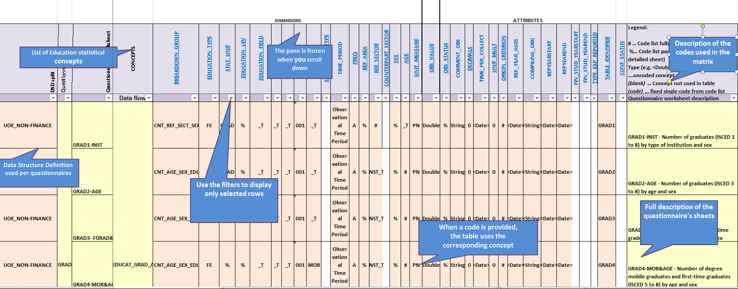

To see which dimensions are used in which DSD and which questionnaires are covered by the DSD, just select a DSD type in the "DSD Split" column filtering. Only tables using the selected data structure are displayed. The coloured columns correspond to the concepts used in the selected DSD.

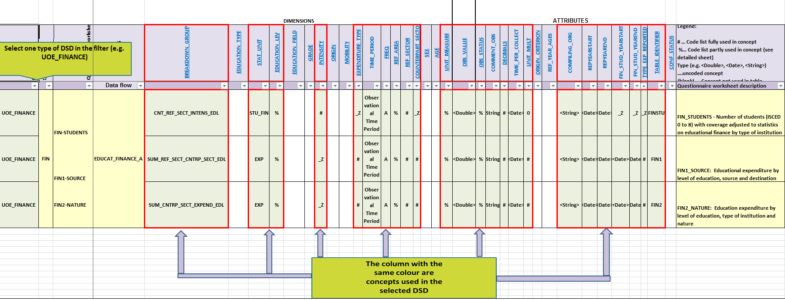

Code List Sheet
Each coded concept is associated to a code list as shown in the “Concept Scheme”. A distinct sheet is created for each code list:

Each code list contains the codes in the first column ("Code"), the labels in the second column ("Description") and, in some cases, additional comments in the third column ("Annotations"). In relevant cases, an additional column describing integrity rules can be added.

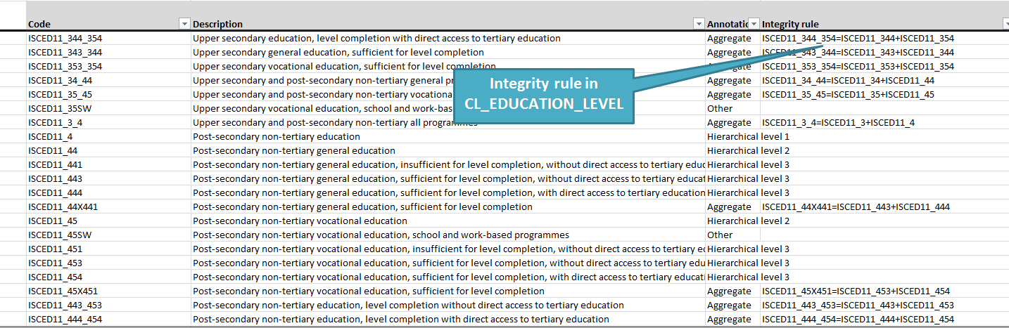

Comparison with previous DSD Matrix

Table 2 below provides an overview of the changes implemented in the new DSD Matrix (2019) compared to the 2014 Matrix.

Table 2: Comparison with previous DSD Matrix

Concept or Code list  affected in new DSD Matrix | Changes compared to previous DSD Matrix
EDUCATION_TYPE | Concept EDU_TYPE replaced with EDUCATION_TYPE
CL_EDUCATION_TYPE | Code list CL_EDU_TYPE replaced with CL_EDUCATION_TYPE
EDUCATION_LEV | Concepts ISCED11P_LEVEL, ISC11P_CAT, ISC11P_SUB merged into new concept EDUCATION_LEV
CL_EDUCATION_LEVEL | Code lists CL_EDU_LEVEL, CL_ISC11P_CAT and CL_ISC11P_SUB, merged into new code list CL_EDUCATION_LEVEL
EDUCATION_FIELD | Concept FIELD replaced with EDUCATION_FIELD
CL_EDUCATION_FIELD | Code list CL_ISCED13_FIELD replaced with CL_EDUCATION_FIELD
CL_GRADE | - All codes in CL_GRADE (e.g. 1, 2 ,3, 4 ….14) now prefixed with G (e.g.: G1, G2, G3, G4……G14)  - Description of code _T "Total: all grades" replaced with "Total"
CL_INTENSITY | Description "Full- and part-time" for code _T replaced with "Total"
ORIGIN | Concept COUNTRY_ORIGIN replaced with ORIGIN
MOBILITY | Concept COUNTRY_CITIZENSHIP replaced with MOBILITY
CL_MOBILITY | Code list CL_AREA attached to old concept COUNTRY_CITIZENSHIP replaced with CL_MOBILITY now attached to new concept MOBILITY
CL_STAT_UNIT | - Code AVG_CLS deleted from code list STAT_UNIT  - Code PERS replaced with PS.  - Code MAN replaced with MGMT  - Codes BEG_MINL, EXP_MINL, HSAL_HQUAL, EXP_MQUAL moved to CL_TEACH_EXPER, but using new codifications  - Codes CLS_MULTIU, CLS_SING, SCH, COMP, STAT_COMPT, NRTEACH added by UIS
BREAKDOWN_GROUP | - New concept
TABLE_ID | - TABLE_ID dimension transformed into attribute
CL_SECTOR | - Code list CL_SECTOR_EDU replaced with CL_SECTOR  - code S1D "Total private" replaced with PRV_NEDUC "Non-educational private sector"  - code S1D_ O "Other non-educational private entities" replaced with PRV_NEDUC_O "Other non-educational private entities"  - Code OUT_INST_T "Outside educational institutions" replaced with _TXINST "Sectors other than educational institutions"  - Labels of codes S1311, S1312, S1313 aligned with National Accounts sector code list. Words "excluding social security" added to the label  - Codes S1PE and GD_SERV deleted
CL_EXPENDITURE_TYPE | - Codes DIR_EXP, NET_PAY and PAY merged into DIR_EXP  - Codes TRF, FAHS, TRF_PAY and NET_TRF merged into TRF  - Codes RD_HE, RD_SEP, GRNT_NTF, INT, PRIN deleted
REPYEARSTART/REPYEAREND FIN_STUD_YEARSTART /FIN_STUD_YEAREND | - Concepts REF_PER_START and FIN_YEAR_START merged into new concept REPYEARSTART  - Concepts REF_PER_END and FIN_YEAR_END merged into new concept REPYEAREND  - New concepts FIN_STUD_YEARSTART and FIN_STUD_YEAREND added in the Matrix. Concepts to be used when FIN-STUD is not aligned with financial year
CL_OBS_STATUS | - Code list CL_OBS_STATUS_EDU replaced with SDMX cross-domain code list CL_OBS_STATUS  As a result, the following changes have been implemented in the questionnaires:  - Code M "Missing value" replaced with O "Missing value"  - Code Z "Not available" replaced with M "Missing value; data cannot exist"  - Code X "Data included in another category" replaced with K "Data included in another category"
UNIT_MEASURE | CL_UNIT_EDU replaced with CL_UNIT
CL_AREA | IMF+CL_AREA+1.0. replaced with SDMX+CL_AREA+2.0 (which represents a combination of reference area codes in M49 and ISO-3611 classifications)

All aggregate codes for ORIGIN concept (e.g. Europe, Europe not specified, Asia, Asia not specified) have been replaced in GRAD and ENRL questionnaires, using the codes from the M49 classification.

Table 3 below provides an overview of the changes implemented in the new GRAD and ENRL questionnaires for the aggregates associated to the ORIGIN concept.

Table 3: Comparison with the previous codes for ORIGIN concept
Code description in the questionnaire | Previous code in GRAD and ENRL questionnaires for ORIGIN | New code in GRAD and ENRL questionnaires for ORIGIN according to M49 classification
Africa not specified | F19 | 577
Total: Africa | F1 | 002
Northern America not specified | A29 | 293
Total: Northern America | A2 | 021
Latin America and the Caribbean not specified | A99 | 741
Total: Latin America and the Caribbean | A9 | 419
Asia not specified | S19 | 490
Total: Asia | S1 | 006
Europe not specified | E19 | 568
Total: Europe | E1 | 007
Oceania not specified | O39 | 527
Total: Oceania | O3 | 009
From abroad but country of origin not specified | W19 | 898
Total: All countries of origin | W1 | 001

SDMX Artefacts
The technical representations of the data structures and their related concepts and code lists are stored as so-called "SDMX artefacts" in the SDMX Global Registry. Once the SDMX reporting framework is used in production, the SDMX Global Registry serves as a central repository for all internationally agreed Data Structure Definitions and their related objects.

5.1 UOE Education implementation model
The approach in UOE Education was to start with the "Education Domain Concepts". In SDMX those are expressed in the Concept Scheme artefact from which the data structures have been derived. Data structures are then used to define multiple data flows. The relevant subset of codes applicable for a specific data exchange will be expressed using the Constraint artefact. The technical implementation model can be visualised as follows:
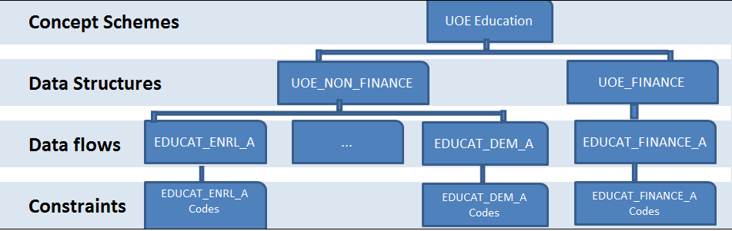

5.2 DSD Split
For optimal representation of the UOE Education reporting framework, the following Data Structure Definitions have been created by the technical group:
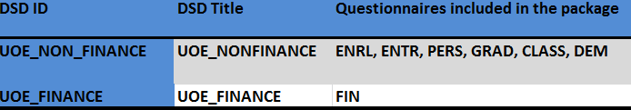

Further details on the dimensions linked to each DSD are shown in the above-mentioned matrix sheet .

5.3 Availability of SDMX Artefacts

The Data Structure Definitions and their related SDMX artefacts are available for download from the SDMX Global Registry.
The screenshots below show where to find the DSDs and related artefacts online and how to download them for local use.
TO VISUALISE THE ARTEFACTS ONLINE:
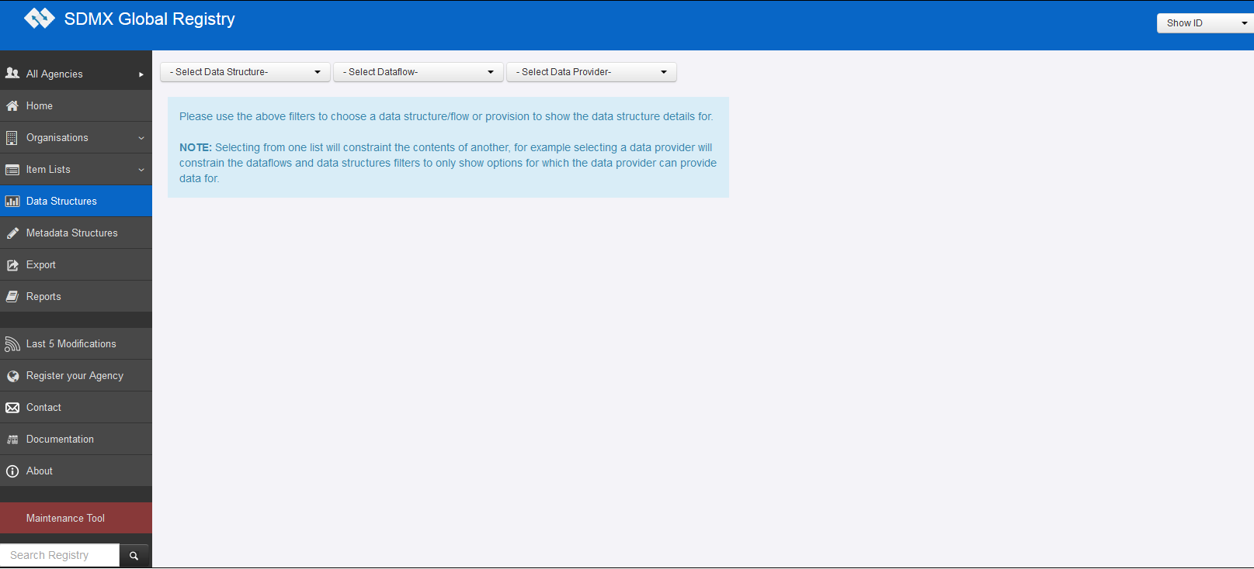
Click here to view the DSD in the Registry
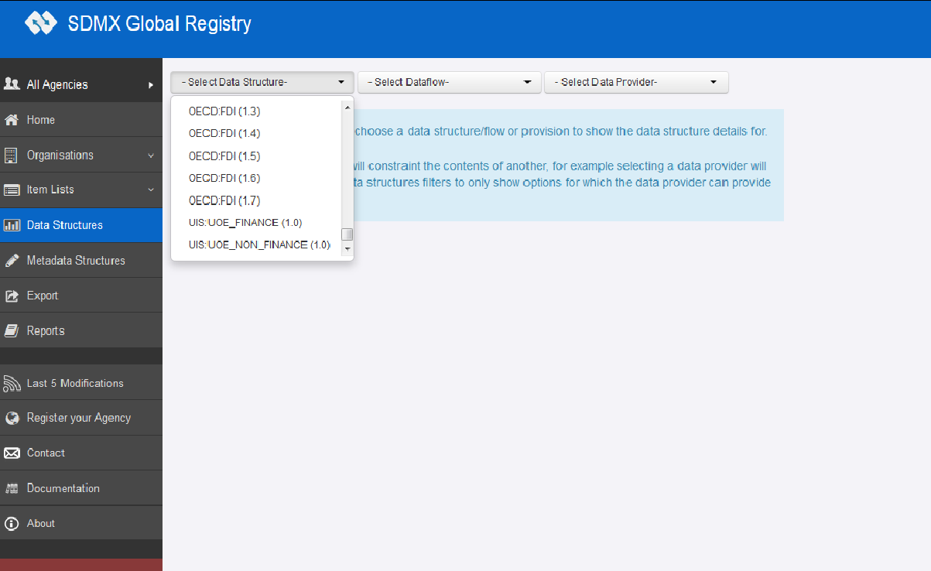
Select DSD from the dropdown list

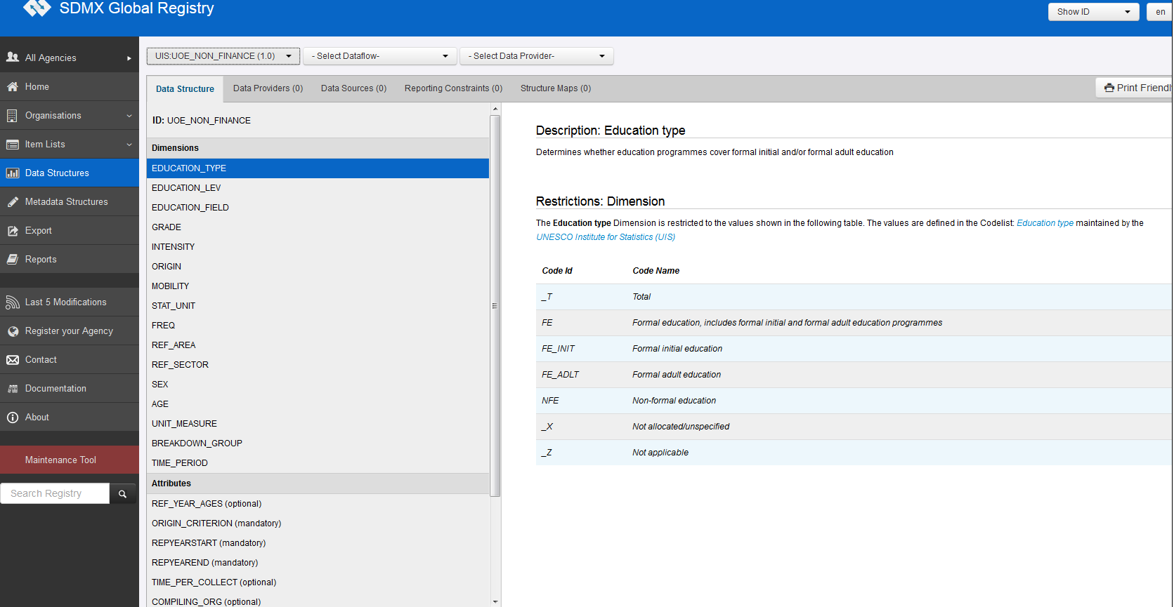
Click on each attribute to see the DSD attributes
Click on each dimension to see the DSD dimensions

TO DOWNLOAD THE ARTEFACTS:
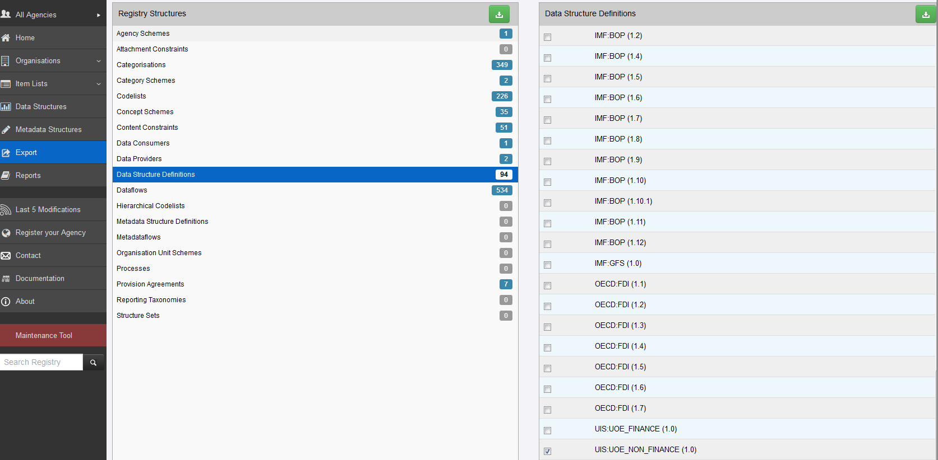
3. Click on the icon to download the selected structure (DSD)
1. Click on Export Data Structure Definition to find the DSD for downloading

2. Tick this button to download the DSD UIS:UOE_NON_FINANCE(1.0)

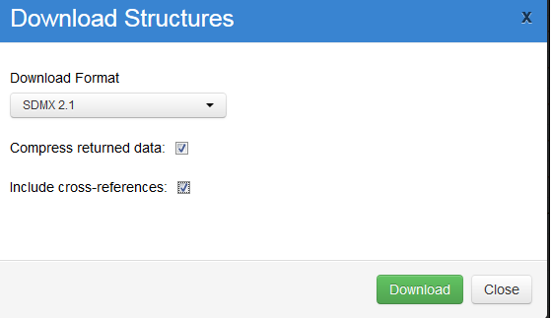
Tick to include the code lists and concepts into the xml file
Select the SDMX version

Launch the download

Annex
Three questionnaires (LANG Questionnaire, REGIO Questionnaire and CREDMOB Questionnaire) are specific to Eurostat, which means that the data exchange does not involve OECD nor UNESCO.
Table 4 below lists the concepts used in the Eurostat-specific data collection on education.

Table 4: Concepts used in the Eurostat DSDs for education

Concept ID | Concept Definition
EDUCATION_LEV | An ordered set which groups and classifies education programmes according to the knowledge, skills, competencies and qualifications which they are designed to impart
STAT_UNIT | Entity for which information is sought and for which statistics are ultimately compiled
BREAKDOWN_GROUP | Group of dimensions according to which the data are decomposed
TIME_PERIOD | Timespan or point in time to which the observation actually refers
OBS_VALUE | Value of a particular variable
FREQ | Time interval at which observations occur over a given time period
REF_AREA | Country or geographic area to which the measured statistical phenomenon relates
SEX | State of being male or female
AGE | Length of time that an entity has lived or existed
UNIT_MEASURE | Unit in which the data values are expressed
COUNTRY_DESTINATION | Country of destination of statistical units
MOB_SCHEME | Type of mobility scheme, i.e. under EU programmes (e.g. ERASMUS or other EU programmes), under other international/national programmes, other programmes; including/excluding degree mobile graduates
MOB_TYPE | Type of mobility, i.e. study period and/or work placement
TABLE_IDENTIFIER | List of current data collection tables
REF_YEAR_AGES | Reference date for ages
REPYEARSTART | Start of the reference period. For example, start of school year or financial year
REPYEAREND | End of reference period. For example, end of school year or financial year
OBS_STATUS | Information on the quality of a value or an unusual or missing value
CONF_STATUS | Information about the confidentiality status of the object to which this attribute is attached
COMMENT_OBS | Comments to the observation value
DECIMALS | Number of digits of an observation to the right of a decimal point
TIME_PER_COLLECT | Dates or periods during which the observations have been collected for the target reference period
UNIT_MULT | Exponent in base 10 used for calculating the actual value in the unit of measure

Three additional concepts are used in Eurostat questionnaires but not in the common UOE questionnaires:

- COUNTRY_DESTINATION
- MOB_SCHEME
- MOB_TYPE

DSD Split for EUROSTAT data collection
For optimal representation of the EUROSTAT Education reporting framework, the following Data Structure Definitions have been created by the technical group:
- ESTAT+LANG+1.0
- ESTAT+REGIO+1.0
- ESTAT+CREDMOB+1.1
Further details on the dimensions linked to each DSD are shown in the matrix sheet.

Availability of SDMX Artefacts for EUROSTAT data collection

The Data Structure Definitions and their related SDMX artefacts are available for download from the SDMX Euro Registry.

The screenshots below show how to find the DSDs and related artefacts online and how to download them for local use.
TO VISUALISE THE ARTEFACTS ONLINE:
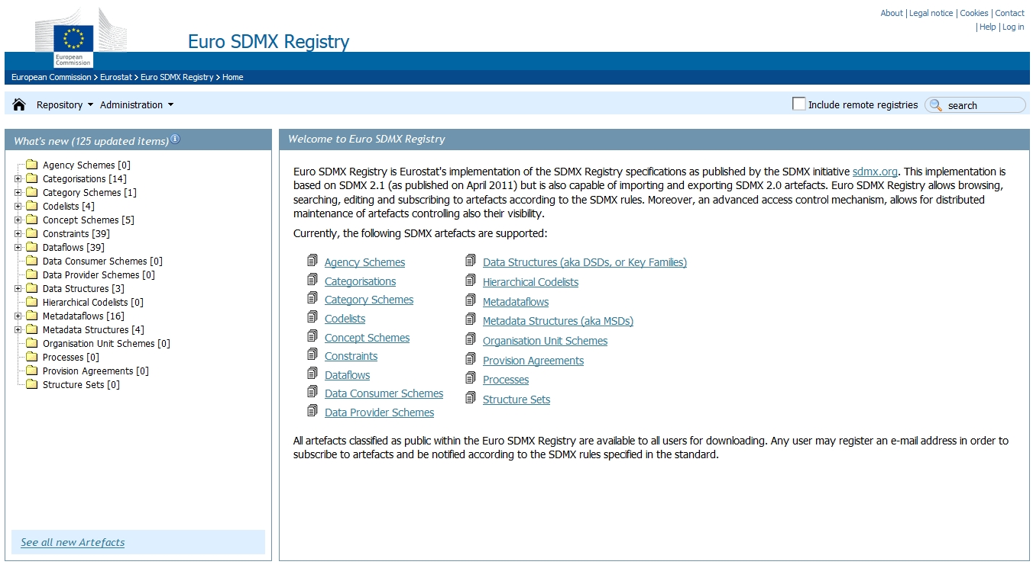
Click
All content in the Euro SDMX Registry

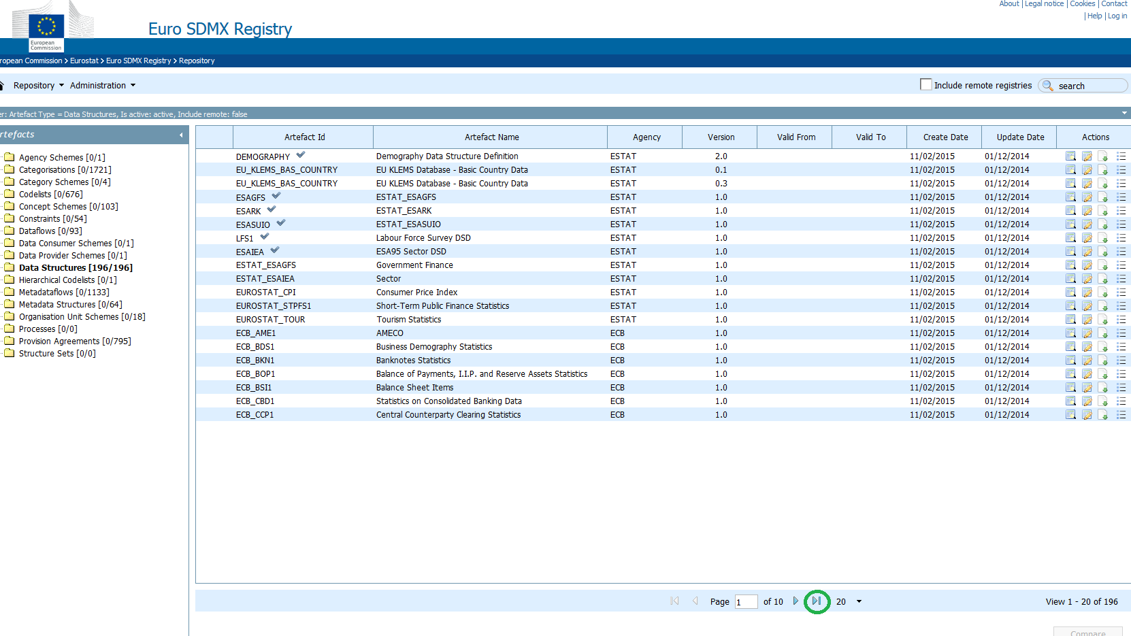
Click

TO DOWNLOAD THE ARTEFACTS:

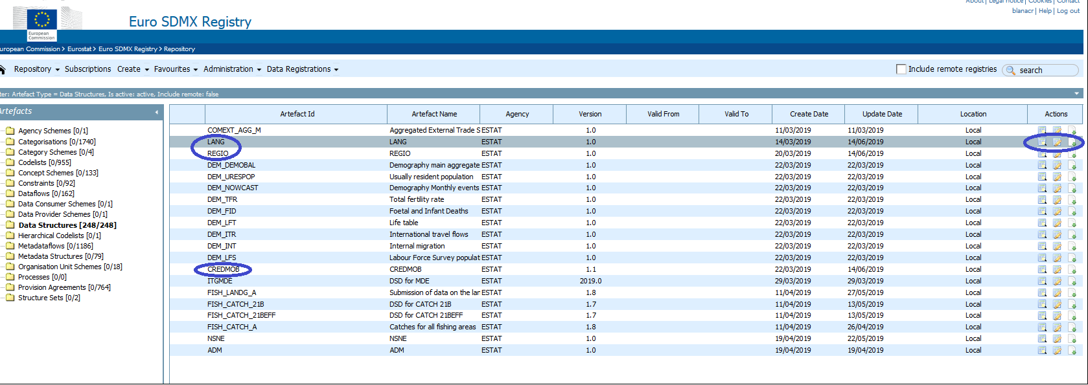

Detailed view
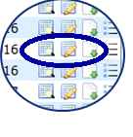
Download
Quick view

Detailed view of the DSD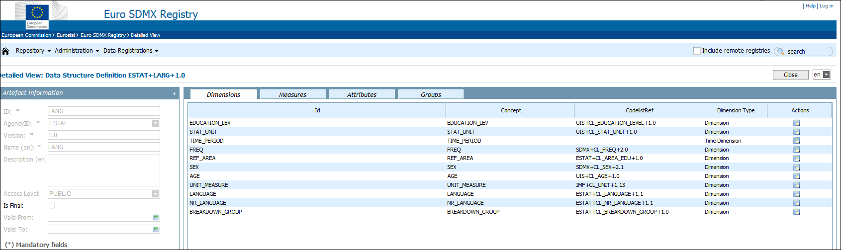
Download of the DSD
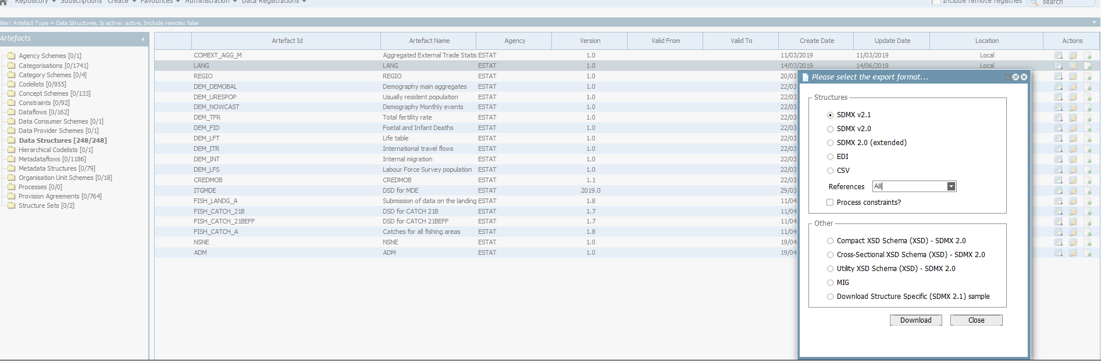
Launch the download

Select SDMX v2.1 or SDMX 2.0 (extended)

