For information of organisational nature please contact us at SDMX2019@ksh.hu

Welcome reception

Venue: Pesti Vigadó
Date: 16 September 2019, 7 pm
Address: H-1051 Budapest, Vigadó tér 2.

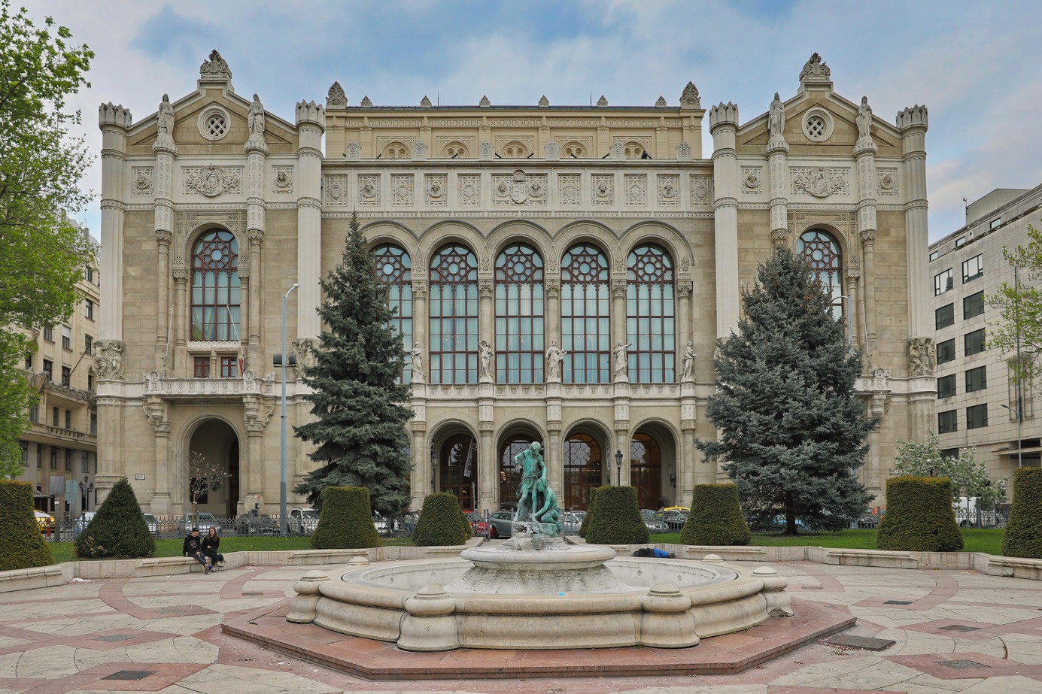

The Vigadó was inaugurated in 1864 and quickly turned into the city’s most prestigious venue for balls and social events. In 1867, Emperor Franz Joseph attended the banquet hosted by the Vigadó in honour of his coronation, and it was also the place where Budapest was born by the merger of the old cities of Pest, Buda and Óbuda (old Buda). During this period Vigadó developed a rich concert life, hosting performances of numerous world famous musicians including Ferenc Liszt, Johann Strauß Jr, Debussy, Sviatloslav Richter, etc.
The building has been recently restored to its full former grandeur under the motto "Art in the Centre".
Practical information about Hungary /Budapest
Hungary is a landlocked country in the heart of Europe, with a population of around 9.8 million people. The official language is Hungarian, a Uralic language completely different from the language of its neighbouring countries. It is also known as “the land of waters,” as it is not only home to the largest lake in Central Europe called Balaton, but also has over a thousand of thermal water springs scattered around the country. The culture and people of Hungary also show a great variety of unique traditions, customs and cuisine, incorporating the heritage of a thousand years of history.
Budapest, a lively and welcoming capital united by the River Danube with hills and valleys on one side, and plains on the other, connected with a series of graceful bridges spanning the river, offers a unique panorama. In addition to aesthetic assets, Budapest also boasts many historical treasures.
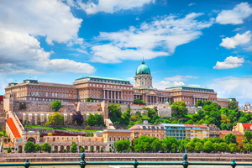
The first major settlement was the ancient Aquincum, originally a Celtic community, later the Roman capital of Lower Pannonia and the border province of the Roman Empire. Visitors can also find buildings and baths constructed and reconstructed during the Ottoman occupation in the 16th and 17th centuries, churches and museums built during the reign of the Habsburgs and numerous other beautiful sights spectacularly demonstrating the various historical periods of the capital city.
Many different populations – Tartars and Turks the most – have left their footprints in Budapest; millions of people have lived here and created a colourful culture.
The city of Budapest was officially formed in November 1873 by the merger of the neighbouring cities of Pest, Buda and Óbuda. Since 1987, the area extending from Margaret Bridge to Szabadság (Liberty) Bridge, including the Castle District of Buda and one of the largest Parliament buildings, has been included in the World Heritage List.
After the 1990s, the Hungarian capital made its first steps on a long journey of development to turn Budapest into a genuine European city where the past and the present are joined together in harmony.
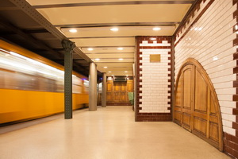
Some interesting facts about Budapest:
- Budapest remains the only capital city in the world that is rich in thermal waters with healing qualities. More than a hundred medicinal hot springs supply most of the spas.
- It is the only capital in the world which has caves of significant size and length underneath its buildings and streets. More than two hundred caves are known under the Buda side of the town.
- It has the oldest electrified underground railway system on the European continent, and the second-oldest electrically operated underground railway in the world: Underground Line 1 or Yellow Line (Millennium Underground).

Local Information

Population of Hungary: 9 877 365 (01.01.2018)
Capital: Budapest
Population of Budapest: 1 749 734 (01.01.2017)
Official language: Hungarian (Magyar)
Area: 93 030 km²
Time zone: CET (UTC+1)
In summer: CEST (UTC+2)
Internet TLD: .hu
Calling code: +36
Electricity: 230 V/50 Hz (more information about plugs and sockets)
Currency: Hungarian Forint (HUF)
Coins: 5, 10, 20, 50, 100, 200 HUF
Banknotes: 500, 1000, 2000, 5000, 10000, 20000 HUF
Average temperatures in September: max. 21°C, min. 16°C

Currency/banking
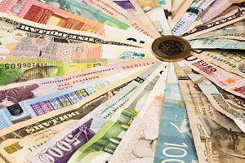
The Hungarian Forint (HUF) is the official currency in Hungary. Exchange rate: 1 Euro = 314.33 HUF (18.03.2019).
It is advisable to change money after arriving in Hungary at official places that have published exchange rates (banks, change offices, hotels, travel agencies).
International credit and debit cards are accepted forms of payment in most hotels, restaurants and shops.

Tipping
Restaurants: service is sometimes included in the bill; otherwise it is customary to leave a tip (5–10% of the total).
Taxis: it is common to tip taxi drivers with the same percentage of the total fare or to round up the charge by about 100–200 forints for a typical ride of ten minutes or less. Airport-shuttle drivers will gladly accept a tip of 200–500 forints.

Tourist Information
Weather-wise, September is generally a good month to visit Budapest. Afternoon highs average 20 Celsius, with average night-time lows around 16 Celsius. Mild days like these are perfect for sightseeing in a walking city. September is sunny, although the chances of rain are on the rise. Dressing in layers is key to being comfortable and prepared for changing weather in Budapest in this month.
The following websites provide a bunch of information on sights and events in the city:
- BudapestInfo.hu
- Things to do in Budapest in September
- Budapest Travel & Tourism Guide

Insurance
The organisers do not take responsibility for individual medical, travel or personal insurance, and all delegates are strongly advised to make their own personal insurance arrangements before travelling to the conference. The organisers will not accept any liability for damages and/or losses of any kind, which may be incurred by conference participants or by any persons accompanying them during official activities.
For information about Health Care Service available during your temporary stay in Hungary click here (pdf).

Disclaimer
The clients participate in all events at his/her own risk. Participants are advised to insure themselves against loss, accidents or damage that could be incurred during the Conference. Verbal agreements will not be binding unless they are confirmed in writing. Sole place of jurisdiction is Budapest. Hungarian law is applicable.

Emergency phone numbers

Ambulance: 104
Police: 107
Fire service: 105
Central help number: 112

Passport and Visa Requirements

Participants may need a visa. Please check if a visa is needed for your country.
More information: konzuliszolgalat.kormany.hu/en

Little Hungarian Vocabulary

Magyarország (ma-djar-or-saag) – Hungary
Jó napot kívánok! (yoh nu-pot khee-vha-knock) – Good morning!
Jó étvágyat kívánok! (Yoh-eht-vah-jot khee-vha-knock) – Bon appetit!
Viszontlátásra! (vee-sont-laa-taash-raa) – Goodbye!
Köszönöm! (khoe-se-noem) – Thank you!
Egészségére! (Ag-esh-sheg-eh-reh) – Cheers!
Elnézést! (el-naez-esht) – Excuse me!
Kérem! (khay-rem) – Please!
Igen (egh-an) – Yes
Nem (nam) – No
Gyógyszertár (dgodg-ser-taar) – Pharmacy
Étterem (ai-ther-am) – Restaurant
Reggeli (rhe-ghe-lee) – Breakfast
Ebéd (a-baid) – Lunch
Vacsora (va-cho-rah) – Dinner
Innivaló (in-ni-vha-lo) – Drink
Étel (ai-tel) – Food

Transportation

Arriving at the Budapest Ferenc Liszt International Airport

Budapest Ferenc Liszt International Airport (Hungarian: Budapest Liszt Ferenc Nemzetközi Repülőtér) (IATA: BUD), is the international airport serving the Hungarian capital city of Budapest.

1. Public transport
The direct shuttle bus service, route “100E”, operates between the airport and the city centre (Deák Ferenc tér), with a frequency of 30 minutes. The journey takes about 40 minutes and it is available with an airport shuttle bus single ticket. You can purchase the ticket at BKK customer service centres, ticket offices and vending machines and it costs 900 HUF.
Public bus “200E” is also available, and circulates between the airport and Kőbánya-Kispest underground terminal. However, due the reconstruction work on the line we recommend the other transportation options to get to the city centre.
2. Airport Shuttle-Minibus service
The Airport Shuttle-Minibus service escorts its passengers between Budapest Liszt Ferenc International Airport and any point of Budapest.
More information: https://www.minibud.hu/en

3. Airport Taxi
Főtaxi is the contracted/official taxi company of the airport. Főtaxi ensures the safety and comfort of passengers by only working with experienced drivers who speak at least one foreign language and a car fleet consisting of vehicles newer than 5 years. All cars are equipped with a POS terminal, therefore credit cards are also accepted. Reservations can be made in person at the Főtaxi booths located at the exits at Terminals 2A and 2B. At the taxi rank in front of the stands, taxis are parking continuously waiting for passengers. Please make sure you reserve a taxi through the official taxi booths, it is not recommended to take private/individual taxis.
A Taxi Decree was introduced in Hungary regulating the price of the taxis at a fixed kilometre-based fare of 300 HUF/Km (0.95 EUR/Km) in addition to the one-off base fare of 700 HUF (2.20 EUR) and waiting fee. A taxi from the airport to the conference venue resp. to one of the recommended hotels costs approx. 8000 HUF (26 EUR).

Arriving by train at Keleti Railway Station
The railway station Budapest Keleti Pályaudvar has a direct connection to certain public transport lines (underground line M2 and M4 and several buses).
General Information on the public transport in Budapest
Public transport in the city of Budapest is supervised by Budapesti Közlekedési Központ (Centre for Budapest Transport). There is a network of several bus-, tram- and trolleybus routes, as well as four underground lines. There are also five suburban railway lines (HÉV) serving the outskirts of the city. Most services operate from around 5 o'clock in the morning until about 11 o'clock at night.
Transportation tickets should be purchased before boarding the bus, tram or entering the underground and need to be validated upon entry. Machines either punch the ticket or validate it by stamping the date and time of travel. Please do not forget to validate a new single ticket every time you change vehicles except when changing between metro lines.
Tickets are often checked while riding the vehicles or at the underground exits by controllers wearing arm-band and a photo-ID. You should always keep your ticket at all times till you exit the station or leave the vehicle.
Tickets are available at Underground stations, Newsagents, Tourinform offices, ticket machines at some bus and tram stops.
For more information, please click here.
Trip planner
Recommended tickets for your stay:
Single ticket: Valid for a single uninterrupted trip HUF 350
Block of 10: The block contains 10 single tickets HUF 3000
24-hour Budapest-travelcard: Valid for 24 hours from the indicated date and time (month, day, hour, minute) for an unlimited number of trips within the administrative boundaries of Budapest HUF 1650
72-hour Budapest-travel card: Valid for 72 hours from the indicated date and time (month, day, and hour, minute) for an unlimited number of trips within the administrative boundaries of Budapest HUF 4150

Recommended Hotels

Carlton Hotel Budapest****
When booking a room at Carlton Hotel Budapest, please use the reservation code “SDMX 2019” to obtain the negotiated special rate.
Website: http://www.carltonhotel.hu/index.htm
Email: carltonhotel@t-online.hu
Single Room: EUR 95.-/day/room
Double Room: EUR 120.-/day/room

Prestige Hotel Budapest ****
When booking a room at Prestige Hotel Budapest, please use the reservation code “SDMX 2019” to obtain the negotiated special rates held until 15th August.
Website: https://prestigehotelbudapest.com/
Email: prestigebudapest@zeinahotels.com
Single Room: EUR 200.-/day/room
Double Room: 215.-/day/room

Sofitel Budapest Chain Bridge*****
When booking a room at Sofitel Budapest Chain Bridge, please use the booking form of the hotel to obtain the negotiated special rates held until 1st July.
Website: https://sofitel.accorhotels.com/gb/hotel-3229-sofitel-budapest-chain-bridge/index.shtml
Email: H3229-SL8@sofitel.com
Single Room: EUR 250.-/day/room
Double Room: EUR 278.-/day/room

Starlight Suiten Hotel Budapest****
Website: https://www.starlighthotels.com/en/budapest/
Email: reservation.starlight@cpihotels.com

Parlament Hotel****
Website: http://www.parlament-hotel.hu/
Email: reservation@parlament-hotel.hu

Restaurants in the neighbourhood

Mák Bistro
Website: http://mak.hu/en/#menu
Map

Trattoria Pomo D’Oro Italian Restaurant
Website: http://pomodorobudapest.com/en/menu
Map

Hanoi Pho Vietnamese Restaurant
Website: http://www.hanoipho.hu/konyhafonok-ajanlata/
Map

Costes Downtown
Website: http://costesdowntown.hu/en/menu/
Map

Padthai Wokbar
Website: https://www.padthaiwokbar.com/en/menu/
Map

KNDRY American Steak House&Bar
Website: https://www.knrdy.com/menu_eng.html
Map

Istanbul Kebab&Grill Restaurant
Website: http://istanbulrestaurant.hu/page/etelek
Map

